Adopt a Grave Press Release

Overview

Adopt a Grave is a people funded idea to honour the deceased whilst helping to highlight the beauty of cemeteries. The first graves available for adoption can be found in the enchanting Brompton Cemetery, London.
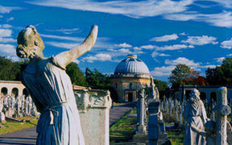
What is Adopt a Grave?

Adopt a Grave gives permission to those who would like to tend a historic grave permission to do so. The purpose of the initiative to help increase footfall and help to promote the use of cemeteries by the general public.
Those who adopt a grave are able to find out the person’s grave they are tending to and feel a connection to the deceased and the surrounding green space where they reside.

The Adopt a Grave trailer (in Technicolor)

The Adopt a Grave Video can be watched, shared and embedded here: http://vimeo.com/112713665

To adopt one of the graves shown in the video above please email your requested grave number to: info@deadsoci.al . The Adopted graves will be allocated over the next month and available to tend from 1st February 2015. 17 graves have been made available for adoption.

What motivates people to Adopt a Grave?

Many of us do not visit green spaces on a regular basis due to a not owning a property with a garden and the environmental conditions in which we live. Due to the nature of urban cities we rarely get to 'work on the land' or immerse ourselves in an area of natural beauty. By granting participants permission to tend a currently untended, historic grave we hope that the natural relationship between participants, nature and death is addressed and somewhat rekindled.
We encourage those who adopt a grave to find out the story about the person whose grave they are tending for. Brompton Cemetery will be available to help support you and any research that you may wish to carryout.

Adopt a Grave Social (meetup)

All of the graves put up for adoption in Brompton Cemetery are in a row next to one another. It is hoped that a small community will be forged over the three month period by participants. We will also have a special meet-up for all of those tending to a grave in March (date TBC).

Terms & Conditions

There are no legal obligations around adopting a grave, we do however ask that you tend to the grave at least three times over the three month period. After the initial three month period you may want to continue to tend to the grave. If so, you will need to speak to Brompton cemetery about doing so.

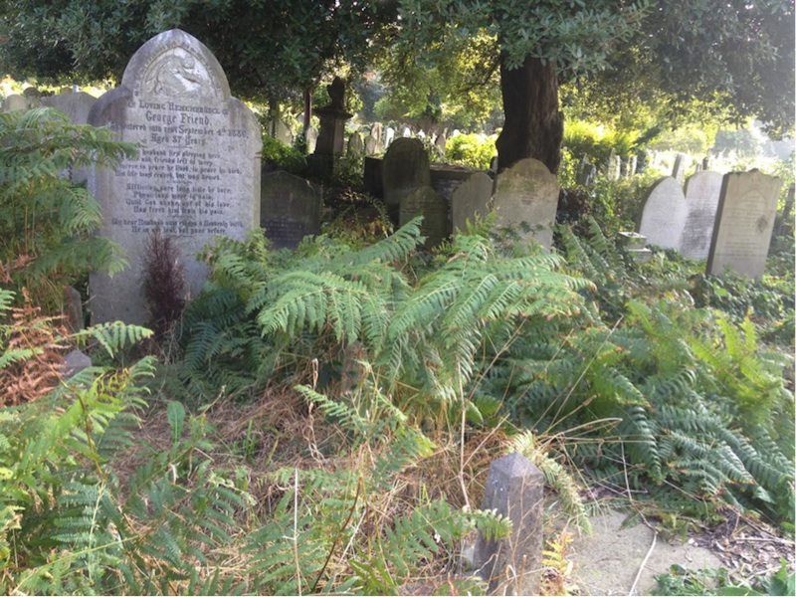

Adopting a Grave in Brompton Cemetery

- Adopt a Grave will start on 1st February 2015 at Brompton Cemetery. Please contact us and state which grave number (from the video) you would like to adopt
- Brompton Cemetery will provide gardening equipment and tools for free to participants.
- The burial and cremation records for Brompton Cemetery can now be accessed online and offline at the cemetery. The complete record collection comprises approximately 205,000 burials for the period 1840 to 1997. You will have access to these if they are of interest.

Thank you

- Thank you to Brompton Cemetery and a special thanks to Robert Stephenson from the 'Friends of Brompton Cemetery'. It is an honor to be supporting your work.
- Adopt a Grave was devised by DeadSocial as part of the London Month of the Dead. Thanks to Stephen & Suzzette from London Month of the Dead for your ongoing support.
- We would like to thank Jon from Death Cafe for donating code for the upcoming Adopt a Grave map tool.

More information about Adopt a Grave can be found at: http://deadsocial.org/features/our-initiatives/adopt-a-grave
More information about Brompton Cemetery can be found here: http://www.brompton-cemetery.org

DeadSocial provides free end of life planning tools, services and tutorials for the connected and creative – www.DeadSocial.org

