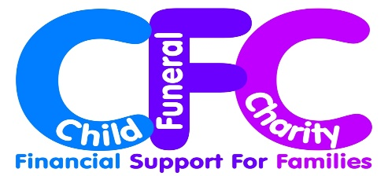

The Child Funeral Charity is pleased to invite you to:

‘It’s Time to Talk’

An Educational Seminar on Child & Baby Funerals

&

The official launch of the Child Funeral Charity

Wednesday 23 July 2014, 10.00am – 4.00pm
At the
National Memorial Arboretum
Croxall Road, Alrewas, Staffordshire, DE13 7AR
£75 fee includes:
All talks, workshops, certificates of attendance for CPD purposes, refreshments and lunch, car parking and an optional tour of the beautiful Memorial Arboretum at 4pm
There will be time for delegates to visit the seminar exhibition
and to see the main memorials

Who is talking? Tim Morris, CEO, ICCM on ‘Current issues in Child and Baby Cremation’, Nicky Whichelow, Director of Greenacres Woodland Burial Parks. ‘Woodland burial options for babies and children’, John Harris, Director of T Cribb & Sons Funeral Directors plus leading child bereavement charities, bereaved parents, experienced celebrant and nurse Alison Kirkham, and more speakers to be announced.
Who is this event for? Any professional working with families who have lost a child, including: registrars, hospice staff, funeral directors, hospital bereavement officers, bereavement counsellors, charity staff, celebrants, faith representatives, bereavement midwives and many other groups.
Would you like a stand? If two people from an organisation are attending, then we are pleased to offer you a 6’ exhibition space (including table) for just £25.
www.childfuneralcharity.org.uk

