‘It’s Time to Talk’ - Seminar on Child & Baby Funerals
Wednesday 23 July 2014
10.00am – 4.00pm

BOOKING FORM
Name of Person attending | Organisation & Job Title | Address | Email Address | Phone No

Payment methods:
O Cheque for £75.00 per delegate enclosed (payable to Child Funeral Charity)
O We would like a stand at the exhibition (£25 with 2 attending delegates)
O Payment by direct transfer to Account No 14690260 Sort Code 77-72-18
O Please invoice: Give details of person and address for invoice
……………………………………………………………………………………
Any special requirements or needs?
……………………………………………………………………………………
Return to: Child Funeral Charity, 6 Nene Road, Bicton Industrial Park, Kimbolton, Cambs. PE28 0LF
or email to: enquires@childfuneralcharity.ogr.uk Tel: 01480 276088

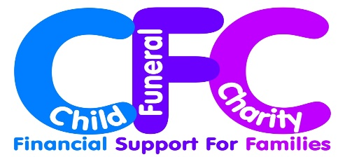
Joining instructions including directions & details of local accommodation will be sent by email two weeks prior to the conference.

