#Bomo2013
6—7 September 2013
M A N I F E S T O

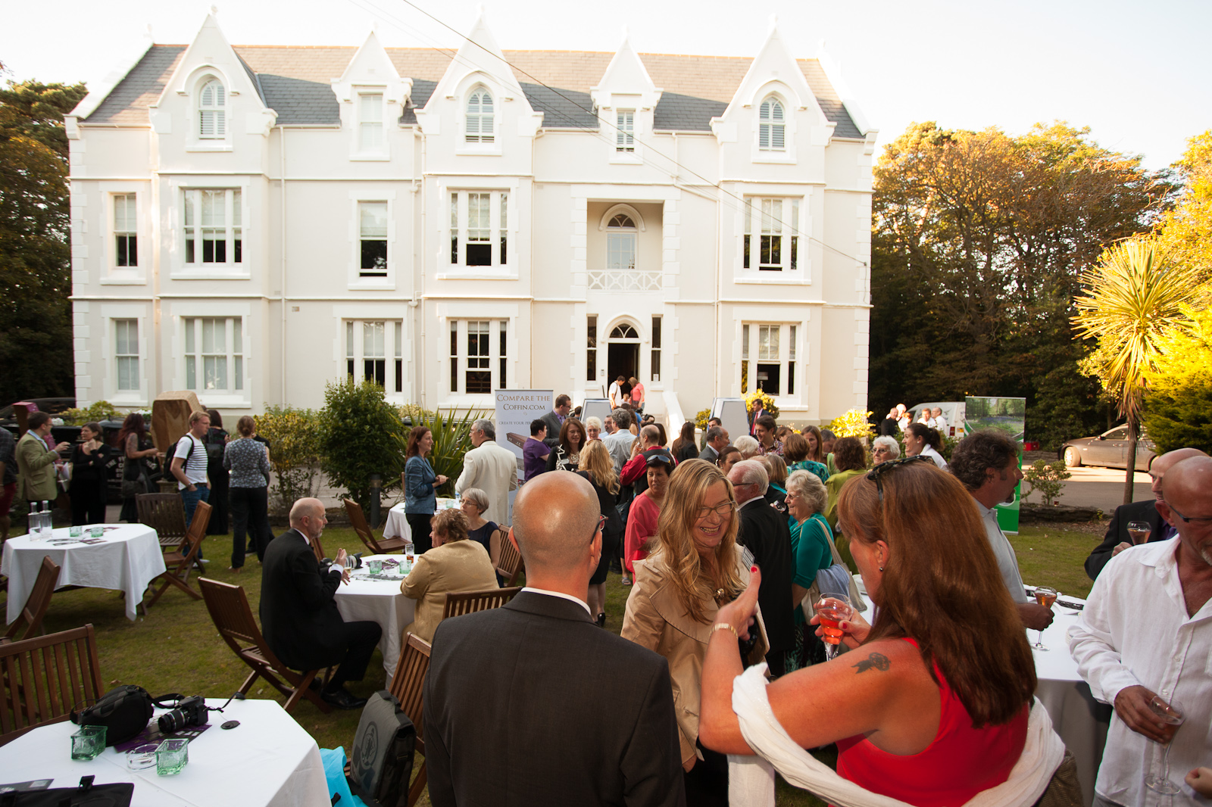

Unique Strong Personality
An inclusive, unstuffy, chatty event which attracts the liveliest minds in Funeralworld and the general public and strives to be useful.

Purpose
- to bring together the tribes of Funeralworld – the undertakers, the celebrants, the makers of merchandise, the raisers of awareness and the consumer advocates
- to promote among them opportunities to connect, exchange views and experiences, share best practice and generate synergistic capital
- to encourage members of the public to drop in, mix, eavesdrop, learn, inquire, question and contribute on an equal footing
- to debate issues around longevity, dying, the care of the dead, funerals, commemoration and grief
- to promote an enrichment of the commemoration of the dead in ways which meet contemporary cultural, emotional and spiritual needs
- to focus on practicality by exploring observances and rituals which are capable of adoption or repurposing by bereaved people in Britain today
- to be welcomingly inclusive -- to reflect and respect all schools of thought from the trad to the progressive
- to promote greater public engagement with dying, death and commemoration and thereby stimulate social change
- to promote the empowerment of the bereaved
- to stage the Good Funeral Awards + dinner dance
- to attract publicity to our work in the media
- to have fun by the sea.

Identity
An ecumenical, ‘department store’ event characterised by co-operation collaboration, equality and mutual respect among all tribes and individuals.
‘Department store’ because some events will be hosted, sponsored even, by an individual org; others will be jointly hosted
Brian Jenner, as organiser, ringmaster and progenitor, has ownership and is our host.

Format
SATURDAY MORNING AND AFTERNOON
- Mingling and nattering
- Hosted discussion groups focussing, severally, on particular concerns of undertakers and celebrants (which anyone may attend)
- Panel event: ‘So you want to do it all yourself?’ Support, guidance and advice for self-helpers & consideration of how undertakers and celebrants can support bereaved people who want to take ownership of all or part of the process.
- Talk: Dr Ben Sessa on the value of psychotropic drugs in palliative care
- Talk: Barbara Chalmers: ‘Get Your Shit Together’.
- Death Cafes.
- Exhibition of merchandise. Provisional title: Ways of Remembering.
SATURDAY EVENING
- The Good Funeral Awards -- industry Oscars presented by Pam St Clement (Pat Butcher from East Enders)
SUNDAY
- Lunch with a star guest (TBA)
Sponsors
Brian is currently seeking sponsors

The venue
Bournemouth – Britain’s Copacabana. In its favour, it is full of cheap faded-grandeur hotels and decent event venues and is in itself a lovely town with a carefree side to it which makes it an agreeable place to get away to, especially for funeralists on a budget. The weather forecast is excellent, so bring your bathing attire. Above all, Bournemouth is the home of Brian, who can negotiate good prices with service providers he knows well. (On the distaff side, sure, it favours those who live in the south. There will always be demand for a Midland venue – but that’s out of the question this time round.)

Please do this now
We need, all of us, to work hard now to create a buzz and attract the brilliant, the beautiful and the brave. Please contact everyone you know and coax them to come.

