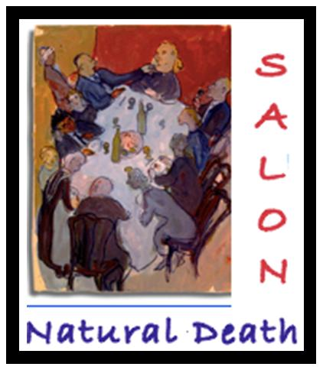
Natural Death Salon
An Afternoon of Film and Death Café
Hosted by Josefine Speyer, showing the award winning film ‘Death Makes Life Possible’ (2013)

A benefit for Natural Death Centre
Celebrating the 25th anniversary of the charity
Sunday 8 May 2016
2.30pm– 6.30pm
Heber Road, London NW2 6AA
Near Willesden Green Underground Station
Suggested donation: £30 (advance booking only)
To book a place please email Josefine on josefine@josefinespeyer.com

Arrive at 2.30pm for a 3pm start of the film (64 minutes running time). The film will be followed at 4.15pm by a Death Café, serving delicious cake, teas and coffee, discussing topics raised in the film and more. Dr. Marilyn Schlitz has kindly allowed us to use this film as a fundraiser for the Natural Death Centre charity.
The film Death Makes Life Possible follows the cultural anthropologist and scientist Marilyn Schlitz, Ph.D., as she explores the mysteries of life and death from a variety of perspectives and world traditions. Sparked by her own near death experience as a teenager, Schlitz has been delving into the nature of consciousness and death for the past three decades.
The film looks at how popular culture in America deals with the ever-present fear many have about our own mortality. Interviews with mental health experts, cultural leaders, and scientists explore the meaning of death and how we can possibly learn to live with less fear. The interviews and evidence presented are interwoven with personal stories of people facing their own death as well as those who report encounters beyond death. The narrative is illustrated with vivid imagery.
Film Review
“A superb training opportunity for professionals who work with families facing death. Told through riveting personal narrative and scientific evidence, the film deepens our awareness of continuity of consciousness to reframe the entire journey.” –Lisa Miller, Ph.D., Professor & Director, Clinical Psychology Program & Spirituality Mind Body Institute, Teachers College, Columbia University
What is a Salon?
The great European tradition of Salons originated in Italy in the 16th Century. Salons became fashionable in France during the 17th, 18th and 19th Century when aristocratic women invited artists and philosophers for discussion and exchange of ideas to their ‘Salon’ (large reception room) in their home. Following this model, the Natural Death Salon offers the chance to talk about death and related topics in the relaxed and comfortable atmosphere of Josefine’s spacious living room, accompanied by some food and drink and in the spirit of openness and congeniality. An opportunity for learining and networking. You are welcome to ask to join the mailing list and be sent invitations to future Salons, held at various times throughout the year. www.facebook.com/naturaldeathsalon

Who is the Natural Death Centre charity?
The Natural Death Centre is a small educational charity founded by Nicholas Albery and Josefine Speyer in April 1991. A leader in the worldwide natural death movement, it is an expert on family-organised and environmentally friendly funerals and gives free, impartial advice on all aspects of death via its helpline and website. It has edited the highly regarded Natural Death Handbook now in its fifth edition (2012) and produces the quarterly online magazine More To Death. To continue its work, the charity depends on donations, fundraising events such as this, book sales and other contributions. Your donation will make a difference! www.naturaldeath.org.uk.

What is a Death Café:
Death Café was set up by Jon Underwood in 2011 in London. He set up a website and invited people everywhere to hold their own Death Cafes according to these guide lines:
At a Death Café people meet to have tea & cake and discuss death. The objective is 'to increase awareness of death with a view to helping people make the most of their (finite) lives'. A Death Cafe is a group directed discussion of death with no particular agenda, objectives or themes. It is a discussion group rather than a grief support or counselling session. There is no selling or promotion of any product or service. It is open to all life styles, faiths and religions. Josefine has held Death Cafes since 2012. She hosts a monthly Death Café in London. www.deathcafe.com/profile/25

Josefine Speyer is the host of the Natural Death Salons. She is a psychotherapist and clinical supervisor with a special interest in grief and loss and death education. Her husband Nicholas Albery and fellow founder of the Natural Death Centre charity they established in April 1991, died in a car accident in 2001. The family organized his funeral without a funeral director and buried him on private land. Josefine was a co-editor of the Natural Death Handbook (2003), and a contributor to the Natural Death Handbook (2012) She offers death education workshops, groups and talks and has hosted Salons at her home for many years, also as part of the Natural Death Centre’s educational program. www.linkedin.com/pub/josefinespeyer/12/876/187

