Alternative hearses

There are vintage hearses and limousines available nationwide. Ask your undertaker. Very few suppliers will deal with you direct.
There are white hearses and there are silver hearses. AW Lymn of Nottingham runs the biggest fleet of Rolls Royces in Europe, all of them silver. See them at: http://www.lymn.co.uk/.
There is a pink hearse. See it at: greenscarriages.co.uk.

Retro hearses
There are retro hearses. The most low-tech of these is a hand bier or handcart, which you would probably be best off sourcing locally. An undertaker is the person best able to help you find one.

Horsey hearses
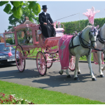
There is the horse-drawn hearse, traditionally pulled by Belgian Blacks with nodding plumes of ostrich feathers. These declined in popularity after the Kray funerals, but are now as popular as ever and available throughout the UK. Timeless and marvellous, they move at everyone’s walking pace. Make sure you or one of yours rides on it, not the funeral director.
- Find one near you: type ‘horse-drawn hearse’ + your county into Google.
- Want a pink one? The only one in the country is owned by Elaine Barnard and you can find it here.

Motorcycle hearses
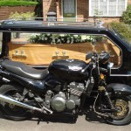
There are motorcycle hearses. Best known and utterly reliable is Motorcycle Funerals run by the Revd Paul Sinclair, the Faster Pastor, a huge character and a national treasure in his own right. “Why,” he asks, “should those who love bikes be last seen in an automobile?”
- Motorcycle Funerals – motorcyclefunerals.com. Ring: 01530 834616. Based in Leicestershire, operates UK-wide.
There are some hearse trailers out there pulled by trikes.
- Trike Funerals -- http://www.trikefuneralsuk.co.uk/

Bicycle hearse
The Rev Paul also has a bicycle hearse. Ring for details.

Vintage lorry hearses
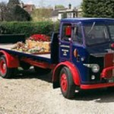
There is a vintage lorry hearse owned and driven by the splendid David Hall. He and his 1950 Leyland Beaver will drive anywhere. David has a gift for creating a display on the lorry’s flat bed which reflects the life of the person who has died.
- vintagelorryfunerals.co.uk. Ring: 01225 865346.
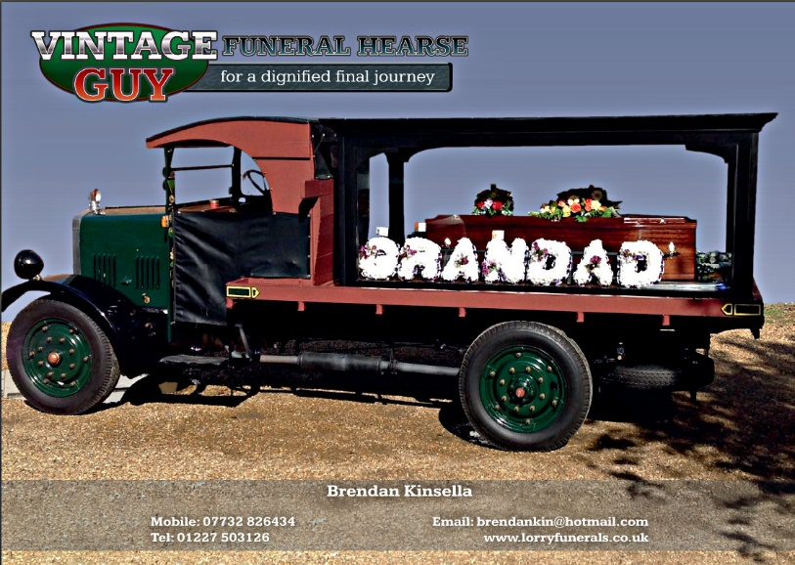
Brendan Kinsella has a 1929 vintage Guy (above). Beautifully restored, a real eyecatcher.

www.vintagefuneralhearse.co.uk

4x4 hearse
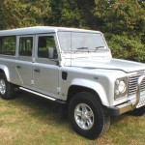
For countryfolk, explorers and other aficionados of the all-terrain vehicle, Alpha 4x4 Funerals offer a silver Land Rover hearse and matching Zambesi ‘limousine’.
- Alpha 4x4 Funerals: www.4x4funerals.co.uk. Ring: 01234 720936. Based in Bedford.

VW hearse
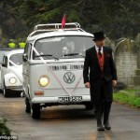
For lovers of the VW camper van, Volkswagen Funerals offer a white VW Type 26 Bay hearse plus fleet of three white stretch Beetles. Alternatively, you can have the 1963 split-screen 21-window Samba. Fantastically lovely people. Based in Staffordshire.
- Volkswagen Funerals: volkswagenfunerals.co.uk. Ring: 01827 709067 or 01827 709045.

Morris Minor hearse
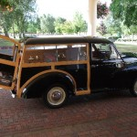
Trudy the Traveller is a lovingly restored and converted 1965 Morris Minor. She is based in Staffordshire and will travel all over central England and further afield from November 2011. We predict a very bright future.
- Morris Minor Hearse Company: http://morrisminorhearse.co.uk/

Citroen Type-H van hearse
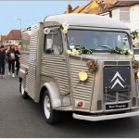
An informal alternative to the big, black hearse, the Citroen Type-H hearse has a friendly appearance and is immaculately presented.
Bon Voyage hearse -- http://www.bonvoyagehearse.co.uk/

Hotrod hearse
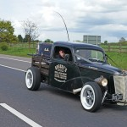
It's a Fordson hotrod, nice looking, supplied by the Final Cruise Co. Good website. They'll customise your coffin, too. No user reviews yet.
- Final Cruise Co http://thefinalcruise.co.uk/

Hummer hearse
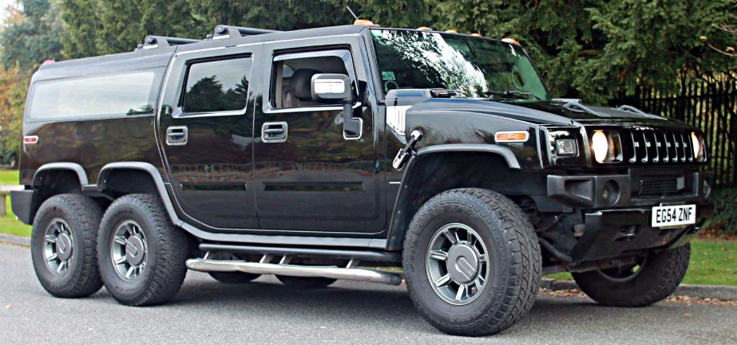

For the petrolhead in your life, a beautifully converted Humvee.
Contact Trevor Holyoak at www.hummerhearse.co.uk

Only Fools and Horses Del Boy Reliant van hearse
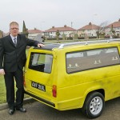
It's Del Boy's Reliant 3-wheeler van towing a converted, stretch Reliant. No user reviews yet, but we have a very good feeling about this.
- Only Fools and Hearses http://www.onlyfoolsandhearses.co.uk/

Tank hearse
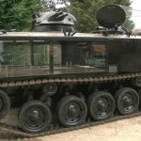
- Tanks-a-Lot http://www.tanklimo.com/tank_hearse_for_hire.htm

Fire engine hearse --
- http://www.classicfireengines.co.uk/

Goth hearse --
- 1972 Cadillac Deville with all the toys: http://www.gothiclimousines.co.uk/hearse.htm

Thanks, we’ll do it ourselves
If you would like to take the person who'd died on their final ride yourself, there is nothing to stop you from using or hiring your own preferred vehicle and taking them in that. Drive down to the undertaker’s, load up and off you go. This way, you can go by any route you want and spend all the time you want – so long as you get to the church or crem on time. Be sure to have enough people to carry the coffin. And be sure to secure the coffin in the vehicle. You don’t want it surging forward when you brake.

ENDS

